Surcharge Types: The Surcharge Types tab holds the list of eligible CNH surcharge types that can occur during the ordering and invoices processes.

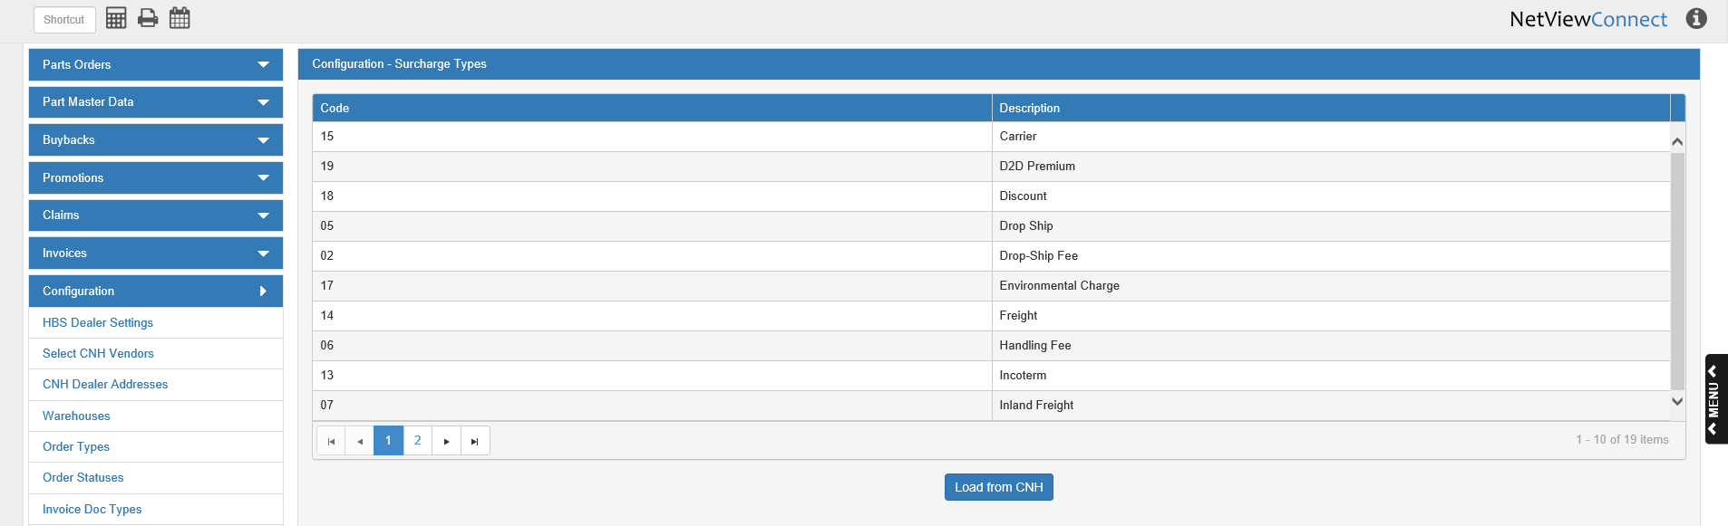

Code: This column holds the CNH surcharge type code.

Description: This column holds the type description (Carrier, Discount, etc.).

Load from CNH: When you first open CNH Connect (CSPS), you will need to load this list from CNH, or you will not be able to view any surcharges on your orders. After the button is first clicked, the list will automatically reload every 30 days, but you can click the button at any time to receive the most updated version of the list.

